Vons usually has all of this and the best apples. I usually like to get a few extra apples to share with the girls at night and I usually look to get a couple cheaper ones. I usually only get Fuji or Gala since they are the best.

**Apples**

* 3 Fuji Apples
* 3 Gala Apples
* 1 Green Apple

**5 Crystal Geyser Water (1 Gallon Bottle)**

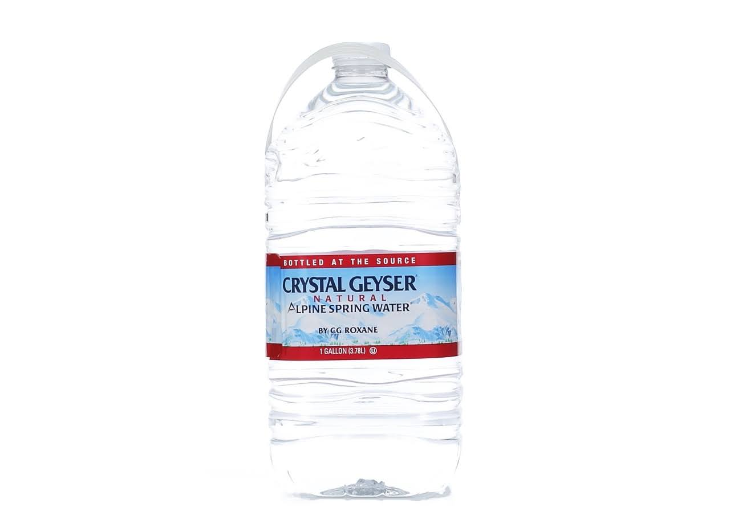

**Lotion**

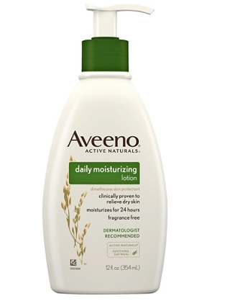

**6 Yoplait Low Fat Strawberry Yogurt**

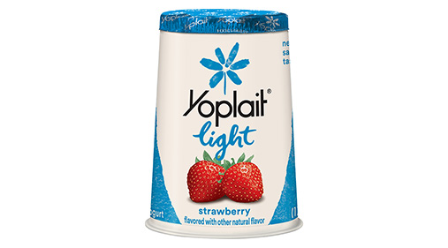

**Wheat Thins Original**

